ECA13 – MICROWAVE ENGINEERING
CO1 APPLICATION-BASED ASSESSMENT (ACADEMIC YEAR 2027–28)
B Prakash (192412025)

APPLICATION PROBLEM
A modern microwave system must deliver power or signals between two subsystems with low loss, a controlled characteristic impedance, a single well-defined mode of propagation and acceptable immunity to interference. The engineer must decide which transmission structure suits the operating band and the application, establish the mode(s) that will propagate, quantify and reduce the losses, and then represent the resulting link as a microwave network described by impedance and scattering parameters.
1. Practical application and problem statement
Modern bridges experience continuous mechanical stress due to traffic loads, wind, temperature variations, and long-term material degradation. Structural health monitoring (SHM) systems use sensors to measure parameters such as strain, vibration, displacement, and temperature. The collected data must be transferred reliably from sensor-interface units to a monitoring station so engineers can assess the bridge's structural condition.
A microwave communication link can transfer these measurements between monitoring units and a nearby control station. Inside the transmitter and receiver equipment, coaxial cables, microstrip lines, striplines, or waveguides carry the RF signals between the radio, filters, amplifiers, and antenna interfaces.
Engineering problem: Design and evaluate a low-loss, impedance-matched microwave transmission network for a bridge-monitoring communication unit. The network must provide reliable signal transfer, acceptable return loss, sufficient bandwidth, electromagnetic compatibility, and stable operation under practical environmental and manufacturing variations.
The assessment will focus on the 50 Ω RF interconnect network inside the bridge-monitoring radio unit, rather than attempting to design the antenna itself.
This is a suitable CO1 application because it requires the analysis of electromagnetic-wave propagation, transmission structures, operating modes, attenuation, impedance matching, and microwave network parameters.
2. Operating requirements and design targets
The following numerical values are proposed academic design targets, not measured results or mandatory bridge-monitoring standards. They provide a consistent basis for calculations and simulation.
Parameter | Proposed requirement
Application | Bridge structural health monitoring communication unit
Category | Civil engineering
Operating frequency | 5.8 GHz
Operating band | 5.725–5.875 GHz, subject to applicable local spectrum rules
Reference impedance | 50 Ω
Selected structure | Microstrip transmission line
Substrate | Rogers RO4350B, nominal \(\varepsilon_r=3.48\)
Substrate thickness | 0.762 mm
RF interconnect length | 100 mm
Maximum insertion loss | 1.0 dB over 100 mm, including transitions
Minimum return loss | 15 dB
Maximum VSWR | Approximately 1.43
Isolation target | At least 30 dB between adjacent RF paths, where applicable
RF power level | Up to +20 dBm (100 mW)
PCB area allocated to RF path | Within 50 mm × 20 mm
Illustrative budget | ₹3,000 for the RF interconnect prototype, excluding instruments
Environmental requirement | Stable operation across the intended temperature and humidity range
EMC requirement | Controlled grounding, shielding, and limited unwanted coupling

The isolation, loss, and budget figures are design goals to be verified against the selected components, fabrication process, and test equipment.
Why choose 5.8 GHz?
Band | Wavelength in free space | Advantages | Limitations
2.4 GHz | 125 mm | Larger components, generally less frequency-dependent attenuation | Longer wavelength and potentially greater antenna/interconnect dimensions
5.8 GHz | 51.7 mm | Compact RF components and practical bandwidth for a local communication link | Higher conductor loss and greater sensitivity to fabrication tolerances
24 GHz | 12.5 mm | Very compact components and wide potential bandwidth | Greater free-space path loss at equal distance and transmit power; increased sensitivity to blockage and implementation tolerances

The 5.8 GHz band is selected as a reasonable engineering compromise between compact hardware, available RF components, and bandwidth. It is intended for communication between monitoring equipment and a nearby gateway, not as a claim that every bridge sensor must operate at this frequency.
Historical development and engineering relevance
The theoretical foundation of microwave transmission comes from Maxwell's electromagnetic field equations and Hertz's experimental demonstration of electromagnetic waves. The development of cavity magnetrons and radar during the twentieth century advanced high-frequency power generation and microwave engineering. Later, semiconductor devices, microwave integrated circuits (MICs), monolithic microwave integrated circuits (MMICs), and modern wireless communication made compact microwave transceivers practical.
Today, structural monitoring uses electronic sensors, communication links, and data processing to assess the condition of civil infrastructure. Research on microwave techniques for bridge monitoring illustrates the broader role of electromagnetic technology in civil engineering.
Practical constraints
- EMI/EMC: RF signals must not interfere with sensor amplifiers, digital acquisition circuits, or nearby wireless systems.
- Environmental conditions: Moisture, corrosion, dust, and temperature changes can affect connectors, substrate properties, and mechanical joints.
- Power and safety: The RF path must tolerate the specified transmit power without excessive heating. The proposed +20 dBm is a circuit design target, not a guarantee of regulatory compliance.
- Reliability: Vibration and repeated thermal cycling can loosen connectors or alter electrical contact quality.
- Cost: Low-loss microwave laminates may cost more than ordinary FR-4; this must be balanced against attenuation and repeatability.

3. Comparison of transmission structures
Four structures are evaluated for the RF path between the radio's active components and its RF output connector.
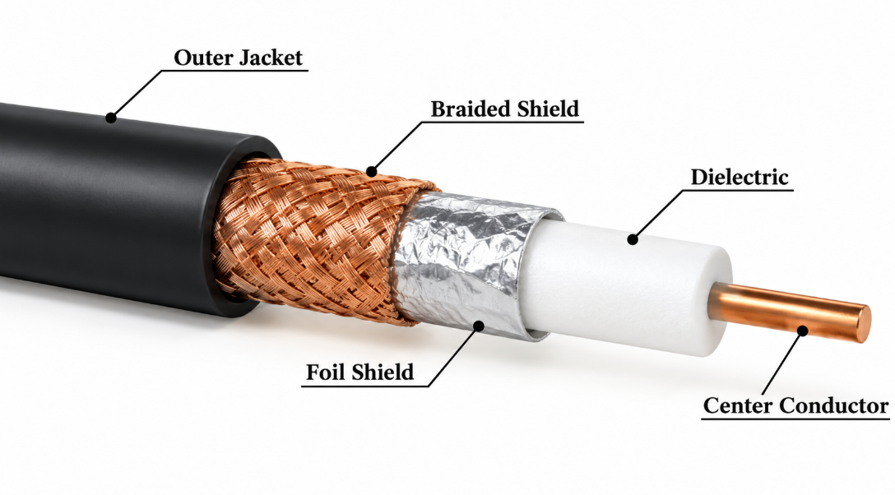
A. Coaxial transmission line
A central conductor, dielectric, and outer conductor confine the electromagnetic field. It supports the fundamental TEM mode, which has no cutoff frequency in the ideal uniform-line model. Coaxial cable is suitable for shielded connections from a radio module to an external connector, but cable attenuation and connector losses must be considered.
B. Rectangular waveguide
A hollow conducting enclosure supports TE and TM modes, with TE\(_{10}\) generally being the dominant mode in a rectangular guide. It can handle substantial microwave power with low conductor loss in appropriate designs, but its size, cost, and cutoff behaviour make it less convenient for a compact 5.8 GHz monitoring radio. A hollow single-conductor waveguide cannot support TEM propagation.
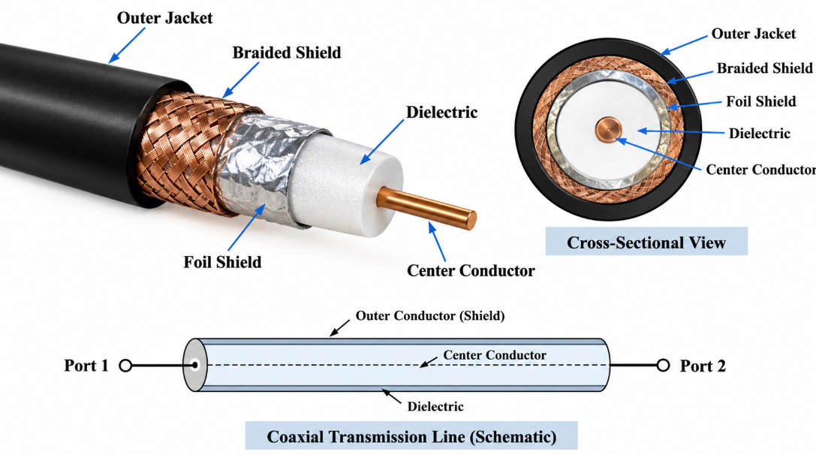

C. Stripline
A conductor is embedded in a dielectric between two ground planes. It supports TEM propagation in the ideal uniform, homogeneous structure and offers good field confinement and shielding. Its buried geometry can make inspection, repair, and prototyping more difficult.

D. Microstrip line — selected
A surface copper trace lies over a dielectric substrate and a ground plane. Its propagation is quasi-TEM because fields occupy both the substrate and the air above it. It is compact, economical to integrate with RF components, and accessible for PCB fabrication and testing.
Weighted selection matrix
Scores range from 1 (poor) to 5 (excellent). These are engineering judgements for the stated application, not measured performance data.
Criterion | Weight | Coaxial | Waveguide | Stripline | Microstrip
5.8 GHz suitability | 20% | 5 | 4 | 5 | 5
Low-loss potential | 20% | 4 | 5 | 4 | 3
Power handling | 10% | 4 | 5 | 3 | 3
Compactness | 15% | 3 | 1 | 4 | 5
Cost and prototyping | 15% | 4 | 2 | 3 | 5
Shielding / field confinement | 10% | 5 | 5 | 5 | 3
RF component integration | 10% | 3 | 2 | 4 | 5
Weighted score / 5 | 100% | 4.05 | 3.55 | 4.10 | 4.20

The weighted score is calculated as
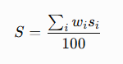
where \(w_i\) is the criterion weight in percentage and \(s_i\) is its score.
Decision: Microstrip is selected for the on-board RF interconnect because integration, compactness, and prototyping are important. Coaxial cable remains the strongest alternative for the shielded connection between the RF board and external equipment.
Sensitivity: If low-loss performance and shielding receive much greater weights, coaxial cable or stripline may rank first. At substantially higher frequencies or power levels, waveguide may become more attractive, depending on dimensions, bandwidth, and the dominant mode.
If frequency is doubled, conductor loss, dielectric loss, dispersion, and higher-order-mode risks must be reassessed. If frequency is halved, the electrical length changes and the same physical layout may no longer satisfy the desired matching and bandwidth requirements.
4. Mathematical model and physical design
4.1 Transmission-line equations
A transmission line is represented using distributed resistance \(R\), inductance \(L\), conductance \(G\), and capacitance \(C\), per unit length. The telegrapher's equations for sinusoidal steady-state signals are
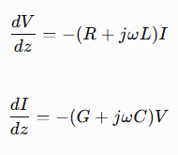
The propagation constant is
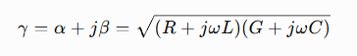
where \(\alpha\) is the attenuation constant and \(\beta\) is the phase constant.
For a low-loss line,
The reflected-wave behaviour is determined by the load impedance:
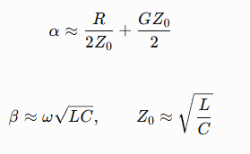
A line with a load impedance close to its characteristic impedance reflects less power and delivers more of the incident signal to the next circuit.
4.2 Propagation modes
Property | TEM | TE | TM | Quasi-TEM
Longitudinal electric field \(E_z\) | Zero | Zero | Nonzero | Small or approximate
Longitudinal magnetic field \(H_z\) | Zero | Nonzero | Nonzero | Small or approximate
Cutoff | No cutoff in an ideal uniform TEM line | Usually has cutoff in a hollow guide | Usually has cutoff in a hollow guide | Approximate line models generally have no waveguide-like dominant-mode cutoff
Dispersion | Ideal TEM line is nondispersive | Frequency-dependent near cutoff | Frequency-dependent near cutoff | May exhibit dispersion
Application here | Coaxial comparison | Waveguide comparison | Waveguide comparison | Selected microstrip

Microstrip is not pure TEM because the electric and magnetic fields extend through two media: the dielectric substrate and the air above it. Their different electromagnetic properties prevent a perfectly uniform TEM field distribution.
4.3 Preliminary microstrip dimensions
The design uses a nominal 50 Ω microstrip on a Rogers RO4350B substrate with:
- Relative permittivity: \(\E_r=3.48\)
- Substrate thickness: \(h=0.762\text{ mm}\)
- Operating frequency: \(f=5.8\text{ GHz}\)
- Line length: \(l=100\text{ mm}\)
Using standard quasi-static microstrip design equations, an initial strip width of approximately \(1.7\text{ mm}\) is a reasonable starting point for a nominal 50 Ω line. The exact width depends on the manufacturer's dielectric data, copper thickness, solder mask, and fabrication details, so it must be refined using a field solver or impedance calculator.
For a preliminary effective relative permittivity of \(\varepsilon_{\text{eff}}=2.7\),
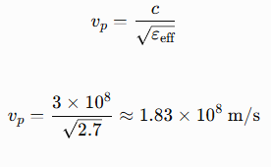
The guided wavelength is
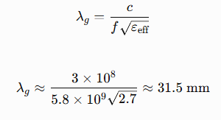
The phase constant is
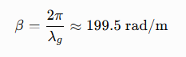
The approximate phase velocity and group velocity are equal in this nondispersive first-order model. Actual microstrip dispersion may make them different.
The group delay for the 100 mm interconnect is approximately
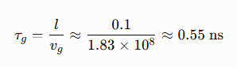
The guide wavelength, group velocity, and phase velocity are approximate because the effective permittivity and dispersion must be verified for the actual layout.
4.4 Cutoff and higher-order modes
Unlike a hollow rectangular waveguide, the selected microstrip line is not sized by choosing a TE\(_{10}\) cutoff frequency. Its fundamental propagation is quasi-TEM. Higher-order substrate, surface-wave, or radiation effects may nevertheless occur as frequency, substrate thickness, and geometry change.
For comparison, the cutoff frequency of the dominant TE\(_{10}\) mode in a rectangular air-filled waveguide is
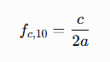
For an illustrative broad-wall dimension \(a=30\text{ mm}\),
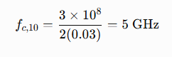
This guide could support TE\(_{10}\) at 5.8 GHz, but the next mode's cutoff must also be checked before claiming single-mode operation. The rectangular guide would be more cumbersome than microstrip for the compact radio board.
Design decision: Use the microstrip structure with an initial strip width of approximately 1.7 mm. Verify the final width, impedance, field distribution, and unwanted-mode behaviour using a suitable EM simulator before fabrication.
5. Attenuation assessment and improvement
Microwave power is lost through conductor resistance, dielectric heating, radiation, connectors and transitions, and impedance mismatch.
For a line with attenuation \(\alpha_{\text{dB}}\) in dB/m,
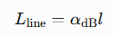
For separate loss mechanisms,
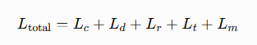
where the terms represent conductor, dielectric, radiation, transition, and mismatch losses, respectively.
5.1 Illustrative loss budget
The following figures are an example budget for a preliminary 100 mm interconnect. They are assumed design estimates for demonstrating the assessment method, not measured or manufacturer-guaranteed losses.
Loss mechanism | Initial design | Improved target
Conductor loss | 0.30 dB | 0.22 dB
Dielectric loss | 0.20 dB | 0.18 dB
Radiation loss | 0.03 dB | 0.02 dB
Connector and transition loss | 0.15 dB | 0.10 dB
Mismatch loss | 0.14 dB | 0.05 dB
Total loss | 0.82 dB | 0.57 dB

The initial total is
The assumed improvement is
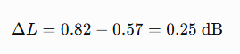
The improvement percentage in dB terms is
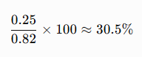
This is a percentage reduction in the numerical dB loss, not a 30.5% reduction in lost RF power. The corresponding power ratio should be calculated separately.
The conductor and dielectric terms are shown as line losses over the specified length. Connector and mismatch terms are additional contributions to the complete path.
5.2 Skin depth and conductor loss
The skin depth of a good conductor is approximately
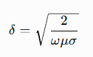
where \(\mu\) is permeability and \(\sigma\) is conductivity. As frequency increases, current becomes concentrated closer to the conductor surface, increasing the importance of surface resistance and copper roughness.

The surface resistance is
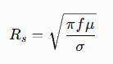
For copper, using \(\sigma\approx5.8\times10^7\text{ S/m}\), \(\mu\approx\mu_0\), and \(f=5.8\text{ GHz}\), the skin depth is approximately \(0.85\,\mu\text{m}\). This shows why surface finish and roughness can materially affect microwave conductor loss.
5.3 Loss-reduction plan
- Use a low-loss substrate rather than assuming ordinary FR-4 will meet the same attenuation target.
- Optimise trace width and ground-plane continuity to reduce conductor loss and unwanted radiation.
- Use a suitable low-loss surface finish and minimise unnecessary copper roughness.
- Keep RF transitions short, maintain a continuous ground return, and use properly mounted 50 Ω connectors.
- Improve matching through impedance optimisation and verify the complete assembly rather than evaluating the bare line alone.
A parametric study should sweep frequency, copper conductivity and roughness, dielectric loss tangent, and substrate thickness. The expected trend is generally higher conductor loss at higher frequency, higher dielectric loss with greater dielectric loss tangent, and increased mismatch loss when geometry or load impedance departs from its target.
Loss decision: The illustrative improved design meets the 1.0 dB target, but acceptance must remain conditional until the line and connector losses are obtained from simulation, component data, or measurement.
6. Microwave network representation and impedance matching
The RF interconnect can be represented as a two-port network. Port 1 is connected to the transmitter-side RF stage, and Port 2 is connected to the receiver-side or output stage.
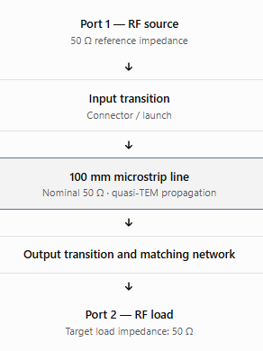
6.1 Equivalent voltage–current and ABCD models
For a uniform transmission line of characteristic impedance \(Z_0\), propagation constant \(\gamma\), and length \(l\), the ABCD matrix is
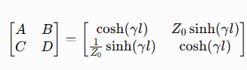
For a lossless line, \(\gamma=j\beta\), giving
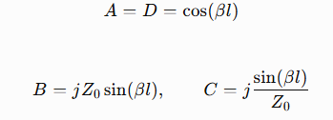
Two cascaded sections can be analysed by multiplying their ABCD matrices:
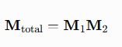
This enables the combined behaviour of the microstrip, connector transition, and matching section to be evaluated.
For a hollow waveguide, voltage and current are not uniquely defined in the same way as for a TEM line. Equivalent quantities can be introduced by selecting a particular waveguide mode and its associated power and impedance definitions.
6.2 Return loss and VSWR
For a 50 Ω transmission line connected to a 60 Ω load,
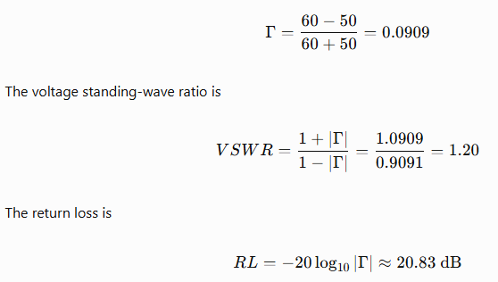
This hypothetical load satisfies the proposed minimum return-loss requirement of 15 dB. However, the complete line and connector assembly must also be checked because the actual input reflection depends on the entire network.
6.3 Matching arrangement
For a real load that is approximately resistive at the design frequency, a quarter-wave transformer provides a simple matching option:
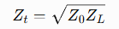
For \(Z_0=50\,\Omega\) and \(Z_L=60\,\Omega\),
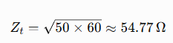
The transformer length at the design frequency is approximately
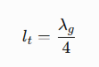
A 54.77 Ω quarter-wave section is a theoretical starting point; the actual microstrip width and effective permittivity must be recalculated for that impedance. The transformer is frequency-dependent, so its performance across the full operating band must be verified.
6.4 Scattering parameters
For a two-port network with equal reference impedances, the incident and reflected waves are related by
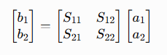
- \(S_{11}\): input reflection coefficient with Port 2 matched.
- \(S_{21}\): forward transmission coefficient.
- \(S_{12}\): reverse transmission coefficient.
- \(S_{22}\): output reflection coefficient with Port 1 matched.
The corresponding return loss and insertion loss are
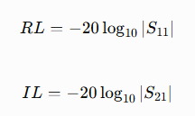
For a passive reciprocal network, \(S_{21}=S_{12}\), assuming consistent port reference impedances. A symmetric network also has \(S_{11}=S_{22}\). An ideal lossless network satisfies \(\mathbf{S}^{\dagger}\mathbf{S}=\mathbf{I}\).
Network verification table
Parameter | Initial target | Final acceptance criterion
Characteristic impedance | 50 Ω | 50 Ω nominal
Return loss | At least 15 dB | At least 15 dB across the operating band
VSWR | At most 1.43 | At most 1.43
Insertion loss | At most 1.0 dB | At most 1.0 dB
Reciprocity | \(S_{21}\approx S_{12}\) | Confirm in simulation or measurement
Matching | 50 Ω source and load | Confirm using \(S_{11}\) and \(S_{22}\)
Losslessness | Not assumed | Evaluate passivity and power balance

Use MATLAB, Python with NumPy, Qucs-S, ADS, CST, or another suitable tool to generate magnitude and phase plots for \(S_{11}\), \(S_{21}\), \(S_{12}\), and \(S_{22}\). No simulated plot should be presented as a measured result.
7. Verification, limitations and robustness
7.1 Verification against requirements
Requirement | Design goal | Method of verification
Operating band | 5.725–5.875 GHz | Frequency sweep
Characteristic impedance | 50 Ω | Impedance calculation and EM simulation
Insertion loss | ≤ 1.0 dB | \(S_{21}\) analysis or VNA measurement
Return loss | ≥ 15 dB | \(S_{11}\) measurement or simulation
VSWR | ≤ 1.43 | Calculate from measured reflection coefficient
Unwanted coupling | Isolation ≥ 30 dB | Multi-port or coupled-path measurement
Power handling | +20 dBm target | Thermal and power-level verification
Environmental robustness | Stable over specified conditions | Temperature, humidity and vibration testing

7.2 Manufacturing tolerance
The preliminary design should be evaluated with at least a ±5% variation in critical dimensions, including substrate thickness and strip width, and with the expected range of dielectric properties.
For example, if a nominal strip width is \(1.7\text{ mm}\), a ±5% tolerance corresponds to
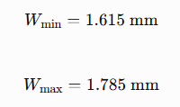
These values define a tolerance sweep, not the resulting impedance error. The actual impedance variation must be calculated using the transmission-line model or an EM field solver. The same procedure should be used to determine the worst-case insertion loss and return loss.
7.3 Assumptions and limitations
The initial calculations assume a uniform substrate, nominal dielectric properties, a reasonably smooth copper surface, and well-constructed transitions. Actual performance can differ because of copper roughness, solder mask, connector launches, ground discontinuities, fabrication variation, and frequency-dependent material properties.
The design also assumes that the RF link is part of a larger monitoring system. The quality of the transmission line alone does not guarantee reliable communication over the complete wireless link.
7.4 EMC and safety testing
- Inspect ground continuity, connector mounting, cable shielding, and enclosure bonding.
- Measure return loss and insertion loss over the complete operating band.
- Check unwanted coupling between neighbouring RF and digital paths.
- Perform conducted and radiated emissions and immunity tests appropriate to the finished equipment.
- Repeat RF measurements after environmental and mechanical stress tests.
- Verify compliance with applicable RF power, spectrum-use, and exposure requirements before deployment.
8. Final engineering decision
Initial design: Conditional acceptance
The preliminary microstrip design is a reasonable candidate because it is compact, economical to integrate, and suitable for the intended 5.8 GHz RF interconnect. Its actual compliance cannot yet be confirmed because the loss budget and matching values are preliminary estimates.
The improved design may be adopted if the completed network demonstrates insertion loss no greater than 1.0 dB, return loss of at least 15 dB, acceptable isolation, stable operation under the stated tolerances, and compliance with applicable EMC and safety requirements.
If the improved design fails verification, the next step is to adjust the trace geometry, improve the connector transitions, refine the matching section, or reconsider stripline or coaxial cable where shielding and lower attenuation justify the additional cost or space.
The final decision must be supported by the calculations, simulated results, and preferably measured RF data. The assumed improvement from 0.82 dB to 0.57 dB is a design illustration and must not be reported as an achieved result.
9. Suggested report conclusion
The proposed microwave transmission network for bridge structural health monitoring demonstrates how transmission-line theory can be applied to a practical civil engineering communication system. Microstrip was selected after comparing coaxial cable, waveguide, stripline, and microstrip using impedance, propagation mode, loss, size, cost, and integration requirements. Preliminary calculations established the dimensions and propagation parameters for a 50 Ω microstrip line operating at 5.8 GHz. Loss-budget analysis identified conductor, dielectric, connector, and mismatch losses as important design considerations. ABCD matrices, impedance matching, and scattering parameters provide the methods needed to evaluate the network. Final adoption depends on independent verification of the operating bandwidth, insertion loss, return loss, isolation, and tolerance sensitivity.
10. References.
- CSIR–Structural Engineering Research Centre, “Structural Health Monitoring.” CSIR - SERC
- “A Review of Microwave Radar Technology for Monitoring Bridges and Other Civil Structures: Applications, Challenges, and Prospects.” Structures, 2026.

